Instruction for Input Files of Airflow Online Tool

TABLE OF CONTENT

EXECUTIVE SUMMARY i
LIST OF FIGURES I
LIST OF TABLES III
1 INTRODUCTION 1
2 MATHEMATIC GOVERNING EQUATIONS 4
2.1 Governing Equations for Matrix 4
2.2 Equations for Specific Nodal Structures 9
2.3 Minor Loss at Nodes 14
3 SOLUTION METHOD 18
3.1 General Introduction of Tool 18
3.2 Treatment for Full Pipes and Particular Nodes 22
3.3 Approaches to Accelerate Convergence 23
3.4 Boundary Conditions at Boundary Nodes 24
4 INSTRUCTIONS FOR TOOL USES 29
4.1 Default Values of Flags in the Tool 29
4.2 Default Values of Coefficient or Factors in the Tool 31
4.3 Inputted Files 33
4.4 Outputted Files 43
4.5 Plotted Figures 49
5 CALIBRATION AND VALIDATION OF TOOL 58
5.1 Coefficients and Factors to be Calibrated 58
5.2 Calibration and Validation 58
5.3 Effects of Boundary Conditions at Laterals 74
5.4 Requirements for Field Data Collection 76
6 SUMMARY AND FUTURE WORKS 78
6.1 Summary 78
6.2 Future Works 79
REFERENCES 80

1 Fundamentals of Air Flow Model

1.1 Equation Matrix
The momentum equation in a pipe as shown in Figure 1 is (Zhang et al. 2020):
$(P_{u}-P_{d})∙A+\frac{1}{2}C_{D}ρ\left(V_{w}-V\right)\left|V_{w}-V\right|BL-\frac{f}{8}ρV\left|V\right|WL=0$ (1)
where subscript $u$ and $d$ represents the parameters at the upstream and downstream end of each pipe respectively; $P$ is air piezometric pressure relative to the datum; $ρ$ is air density; $A$ is the cross sectional area of air flow; C_{D} is drag coefficient on air at air-water interface by water flow when the average water velocity is used; $V_{w}$ is average water velocity in pipe; $V$ is cross-sectional average air velocity in pipe; $L$ is pipe length; $B$ is the width of air-water interface in pipe; $f$ is friction factor; $W$ is air perimeter.
Figure 1 Conceptual model of headspace air flow in a sewer pipe.
The continuity equations at each node is
$\sum_{i=1}^{M}{Q_{i}}+Q_{m}=0$ (2)
where $Q_{i}$ is air flowrate in the pipe connected to the node; subscript i is the index of pipes connected to this node; $M$ is the total number of pipes connected to this node; $Q_{m}$ is the air flowrate into/out of this node via manhole cover opening or ventilator connected to this node, $Q_{m}$ is 0 for a junction.
Thus, the mathematic matrix for the one-dimensional incompressible steady air flow can be established using Eq. 1 and Eq. 2:
$\left[A\right]\left[\begin{matrix}Q_{i} \\ P_{j} \\ ⋮\end{matrix}\right]=0$ (3)
where $A$ is the coefficient matrix of unknown variables.
When this equation matrix is solved, the air flowrate in each pipe and the pressure at each node then are obtained.

1.2 Air Flowrate via Nodal Opening
The air flowrate via the manhole opening as shown in Figure 2 is estimated by the orifice equation (Zhang et al. 2020):
$Q_{o}=C_{sign}S_{o}C_{o}A_{eqv}\sqrt{\frac{2\left|P_{m}-P_{o}\right|}{ρ}}$ (4)
where $Q_{o}$ is the air flowrate via the nodal opening; $C_{sign}=\frac{P_{m}-P_{o}}{\left|P_{m}-P_{o}\right|}$, $C_{sign}=1$ for air emission out from sewer system, $C_{sign}=-1$ for air inducted into sewer system; $S_{o}$ is correction factor and required to be calibrated in the tool; C_{o} is discharge coefficient through an orifice; $A_{eqv}$ is the equivalent area of nodal opening, $A_{eqv}=NA_{o}$ for manhole covers as shown in Figure 4, and $A_{eqv}$ is the opening area for other openings at node; N is the number of pickholes opened at manhole cover; $A_{o}$ is the area of each opened pickhole at manhole cover; $P_{o}$ is the air piezometric pressure right above the manhole cover.
Figure 2 Conceptual model for manhole cover opening.

1.3 Pressurization in Drop Structures
With a drop height higher than 5.0 m, the pressurization in a drop manhole (Figure 3) due to the drag of drop water can be estimated with a correction factor $S_{DS}$ as (Ma et al. (2016)
$∆P=P_{mb}-P_{m}=S_{DS}\frac{3Q_{w}}{πD_{m}^{2}d}C_{d}ρV_{t}{\left(1-\frac{V_{m}}{V_{t}}\right)}^{2}∆Z$ (5)
where $P_{m}$ is the piezometric pressure above the drop node; $P_{mb}$ is the piezometric pressure at the bottom node of drop manhole; $S_{DS}$ is a correction factor introduced to correct the pressurization;$Q_{w}$ is water flowrate dropping in dropshaft; $D_{m}$ is the diameter of drop manhole shaft; $d$ is median water droplet size, $d$ = 2 mm (Ma et al. 2016); $V_{t}$ is terminal velocity of water droplet, $V_{t}$ = 6 m/s (Ma et al. 2016); $C_{d}$ is drag coefficient, $C_{d}$ = 0.4 (Ma et al. 2016); $V_{m}$ is the velocity of air flow dragged by dropping water, which is positive when air moves downwards; $∆Z$ is drop depth of dropping water.
Figure 3 Conceptual model for a standard drop manhole.

2 Files for Input Interface

2.1 GUI of “Sewer System”
In the GUI of “Sewer System”, the information about the pipes and manholes in compuational sewer system, and the water flow information in the system should be uploaded by files.

2.1.1 Pipe Information
Input all necessary information of pipes consisting of the computational sewer system. It should be uploaded in a file of *.csv. This file can include all pipe information of the whole sewer system in a city. The tool can withdraw the necessary pipe information from the file automatically.
The format of *.csv is as follows:
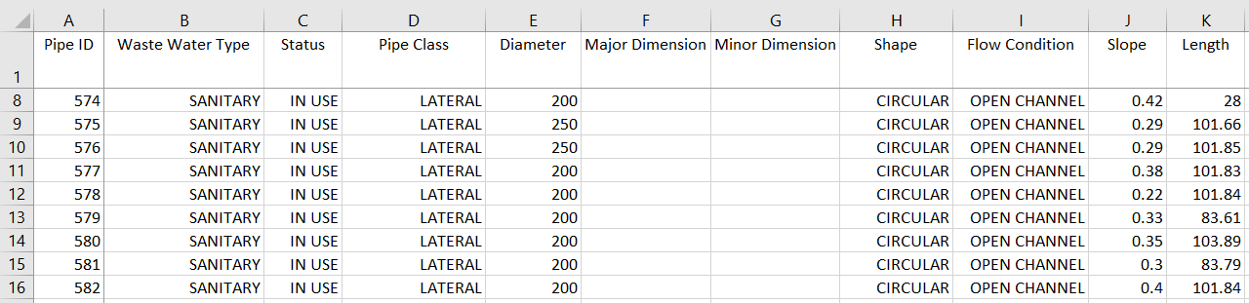
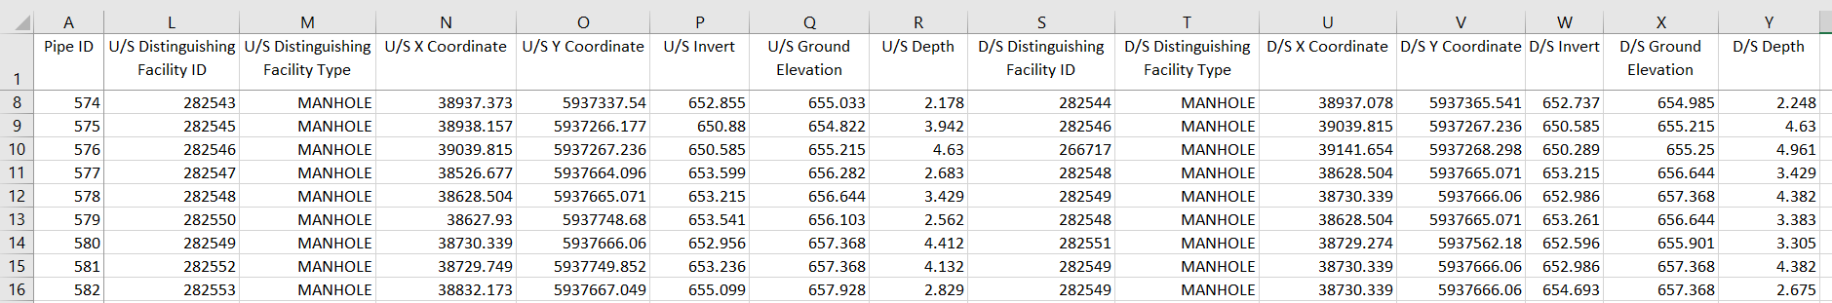
This file is a 25-column Excel file, in which the first column shows the pipe IDs, and the first row shows the name of attributes of pipes. The detail description of each pipe attribute is shown in the following table.
Table Required pipe attributes in file *.csv for pipe information
Name of pipe attribute | Descriptions
Pipe ID | Unique ID for each pipe in system, which should be a combination of pure numbers.
Waste Water Type | Can be one of the following types for each pipe: SANITARY, STORM, COMBINED, etc. Be advised the type STORM should be identified clearly as they will be used in the tool to exclude the storm pipes.
Status | Can be one of the following types for each pipe: ABANDONED, REMOVED, IN USE. The status of ABANDONED, REMOVED should be identified clearly as they will be removed from the computed sewer system.
Pipe Class | Can be one of the following types for each pipe: TRUNK, LATERAL, FORCEMAIN, or others. Be advised that if the pipes are TRUNK and FORCEMAIN, they should be identified clearly as they will be treated differently from others in the tool.
Diameter | The unit is mm. It is the diameter for circular pipes, the height for rectangular pipe, and the height for pipe with other shape.
Major Dimension | The unit is mm. It is width for rectangular pipe and the pipes with shapes other than circular.
Minor Dimension | The unit is mm. It is the 3rd size of the pipe with other shapes excluding circular and rectangular.
Shape | Can be one of the following types for each pipe: CIRCULAR, RECTANGULAR, DOUBLE BARREL PIPE, OVAL, ELIPTICAL, etc. The current tool treat all other shapes other than CIRCULAR, RECTANGULAR, DOUBLE BARREL PIPE as a rectangular pipe.
Flow Condition | Can be one of the following types in each pipe: OPEN CHANNEL, PRESSURE FLOW, etc. This index indicates the water flow in each pipe, and has no effect on air flow simulation as the water flow condition will be judged by the water depth provided by user.
Slope | Pipe slope. The unit is %.
Length | Pipe length. The unit is m.
U/S Distinguishing Facility ID | The node ID at the upstream end of each pipe, which should be a combination of pure numbers.
U/S Distinguishing Facility Type | Can be one of the following types in each pipe: END OF PIPE, MANHOLE, OUTFALL, PIPE CHANGE, PUMP STATION, PIPE SEGMENT, TEE OR YII, VENTILATOR, etc., among which the information related to MANHOLE should be provided in a file for “manhole Information” at the same GUI, and operation information related to PUMP STATION and VENTILATOR should be provided at GUI of “Specific Values” under title “Pump Station Type and Ventilator Air Flow Rate”.
U/S X Coordinate | GIS x coordinate of the upstream end of each pipe. If user chooses to define the computational sewer system at the GUI of “Computation Domain” by uploading “Specified Pipe IDs”, the value in this column can be left to be blank.
U/S Y Coordinate | GIS y coordinate of the upstream end of each pipe. If user chooses to define the computational sewer system at the GUI of “Computation Domain” by uploading “Specified Pipe IDs”, the value in this column can be left to be blank.
U/S Invert | Invert elevation of the upstream end of each pipe, unit is m.
U/S Ground Elevation | Ground elevation of the upstream end of each pipe, unit is m.
U/S Depth | Buried depth of the upstream end of each pipe, unit is m.
D/S Distinguishing Facility ID | The node ID at the downstream end of each pipe, which should be a combination of pure numbers.
D/S Distinguishing Facility Type | Can be one of the following types in each pipe: END OF PIPE, MANHOLE, OUTFALL, PIPE CHANGE, PUMP STATION, PIPE SEGMENT, TEE OR YII, VENTILATOR, etc., among which the information related to MANHOLE should be provided in a file for “manhole Information” at the same GUI, and operation information related to PUMP STATION and VENTILATOR should be provided at GUI of “Specific Values” under title “Pump Station Type and Ventilator Air Flow Rate”.
D/S X Coordinate | GIS x coordinate of the downstream end of each pipe. If user chooses to define the computational sewer system at the GUI of “Computation Domain” by uploading “Specified Pipe IDs”, the value in this column can be left to be blank.
D/S Y Coordinate | GIS y coordinate of the downstream end of each pipe. If user chooses to define the computational sewer system at the GUI of “Computation Domain” by uploading “Specified Pipe IDs”, the value in this column can be left to be blank.
D/S Invert | Invert elevation of the downstream end of each pipe, unit is m.
D/S Ground Elevation | Ground elevation of the downstream end of each pipe, unit is m.
D/S Depth | Buried depth of the downstream end of each pipe, unit is m.

2.1.2 Manhole Information
Input all necessary manhole information consisting of the computed sewer system. It can include all manhole information of the whole sewer system for the city. The tool will withdraw the necessary related information from the file automatically. If there is no manhole in the computed sewer system, the file can be left to be blank.
The format of *.csv is as follows:
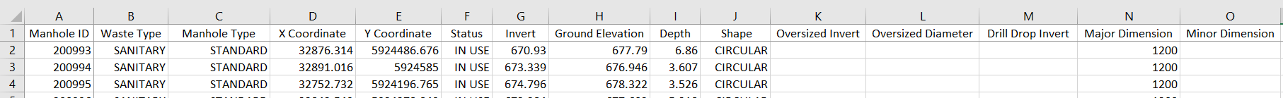
This file is a 15-column Excel file, in which the first column shows the Manhole IDs, and the first row shows the name of manhole attributes. The detail description of each manhole attribute is shown in the following table.
Table Required manhole attributes in a file *.csv for manhole information
Name of manhole attribute | Descriptions
Facility ID | Unique ID for each manhole in system, which should be a combination of pure numbers.
Waste Type | Can be one of the following types for each manhole: SANITARY, STORM, COMBINED, etc.
Manhole Type | Can be one of the following types for each manhole: STANDARD, ACCESS MANHOLE, CATCH BASIN MANHOLE, CHAMBER, DROP MANHOLE, DRILL DROP MANHOLE, INTERIOR DROP MANHOLE, OVERSIZED MANHOLE, etc. The current tool treat DROP MANHOLE, DRILL DROP MANHOLE and INTERIOR DROP MANHOLE as standard drop manholes, all others treated as standard manholes.
X Coordinate | GIS x coordinate of each manhole. If user chooses to define the computational sewer system at the GUI of “Computation Domain” by uploading “Specified Pipe IDs”, the value in this column can be left to be blank.
Y Coordinate | GIS y coordinate of each manhole. If user chooses to define the computational sewer system at the GUI of “Computation Domain” by uploading “Specified Pipe IDs”, the value in this column can be left to be blank.
Status | Can be one of the following types for each manhole: ABANDONED, REMOVED, IN USE. The status of ABANDONED, REMOVED should be identified clearly as they will be removed from the computed sewer system.
Invert | Invert elevation at manhole bottom, unit is m.
Ground Elevation | Ground elevation of each manhole, unit is m.
Depth | Depth of each manhole, unit is m.
Shape | The shape of manhole shaft can be: BOX, CIRCULAR, etc. All shapes other than these two type are treated as a circular
Oversized Invert | For future use.
Oversized Diameter | For future use.
Drill Drop Invert | For future use.
Major Dimension | Diameter for CIRCULAR manhole, and length for BOX manhole in plan view
Minor Dimension | Width for BOX manhole in plan view

2.1.3 Water Flow Data
Provide water flowrate and water depth in each pipe required for the air flow simulation. It can include water flow data only in pipes consisting of the computed sewer system, or data in all pipes for the whole sewer system for the city.
The example of file format is as follows. It is a three-column Excel file. The first row shows the titles. The first column lists the pipe IDs. The second column specifies the corresponding water flowrate in each pipe and the unit is m³/s. The third column specifies the corresponding water depth in each pipe and the unit is m.
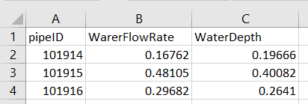

2.2 GUI of “Computation Domain”
At this interface, the computation domain can be defined by uploading files or selecting in map by drawing a polygon.
There are two ways by uploading files to define domain. One is to upload the GIS Boundary Coordinates, another is to upload Specified Pipe IDs

2.2.1 File for GIS Boundary Coordinates
The file *.csv for GIS Boundary Coordinates is a two-column file used to define the computational domain with a polygon surrounding domain of GIS coordinates as shown in following figure. The pipes and other facilities located within the polygon domain consist of the computed sewer system. The detached pipes within the domain will be removed.
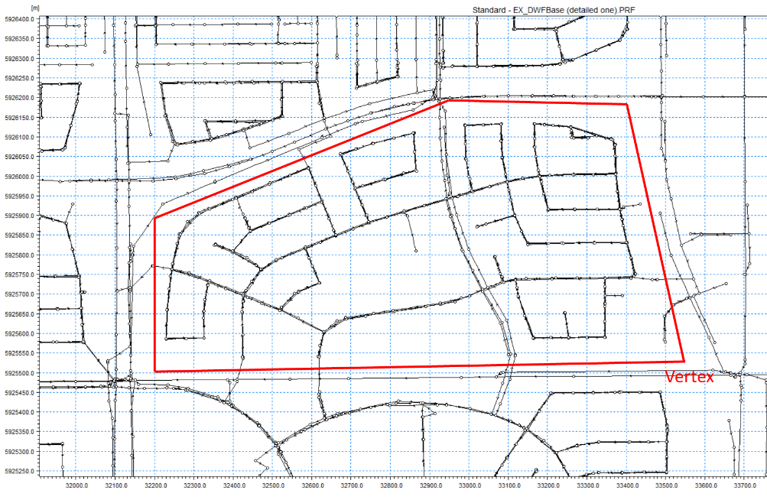
Figure Schematic of computational domain (within the red polygon) defined by GIS coordinates with a polygon domain
The first row of file shows the names of GIS coordinates as shown as follows. Starting from the second row, the first column lists the x-coordinates of the vertexes of the polygon surrounding domain, and the second column lists the corresponding y-coordinates of the vertexes.
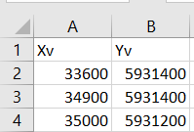

2.2.2 File for Specified Pipe IDs
File *.csv for Specified Pipe IDs is another way to define the computed sewer system. It is a one-column file starting from second row and including all pipe IDs consisting of the computed sewer system. The sample of file format is as follows.
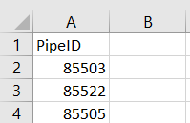

2.3 GUI of “Global Values”
At this interface, the global values for some coefficients and factors are shown in default values as listed in the following table, but users can revised them as they wish. Global value in this tool means this value will be assigned to the coefficient or factor in all related flows in all structures. For example, the default global value of water drag coeff. $C_{D}$ in momentum equation is 0.01, which means this value will be applied to momentum equation for each pipe in the computation domain. If user wants to change the value of $C_{D}$ for a specific pipe, it can be implemented at GUI of “Specific Values”.
Table Default values of coefficients and factors used in the tool and their
Types of Variables | Title at GUI | Default Value | Descriptions
For Air Flow in Pipes | Friction coeff. f | 0.015 | Friction factor of pipe wall used in momentum equation (Eq.1)
For Air Flow in Pipes | Water drag coeff. $C_{D}$ | 0.01 | Water drag coefficient, $C_{D}$, used in momentum equation (Eq.1)
For Air Flow in Pipes | Air density ρ (kg/m³) | 1.225
Related to drop manhole | Water drag coeff. $C_{d}$ | 0.4 | Water drag coefficient, $C_{d}$, used in the pressurization formula in drop manhole (Eq. 5)
Related to drop manhole | Correction factor $S_{DS}$ | 1.0 | Correction factor $S_{DS}$ used in the pressurization formula in drop manhole (Eq. 5)
Related to drop manhole | Critical drop depth (m) | 5.0 | Critical drop depth. If the drop depth of water in a manhole is larger than this critical drop depth, this manhole will be treated as a drop manhole; otherwise this manhole will be treated as a standard manhole without the pressurization of dropping water.
Related to opening of manhole cover (including drop manhole) | Correction factor $S_{o}$ | 1.0 | Correction factor of air leakage via manhole cover opening (Eq. 4)
Related to opening of manhole cover (including drop manhole) | Number of opened pickholes | 4 | Total number of opened pickholes on a manhole cover
Related to opening of manhole cover (including drop manhole) | Discharge coeff. Of orifice | 0.65 | Discharge coefficient $C_{o}$of air flow via a pickhole (Eq. 4)
Others | Retrofitted drop MH ID | 0 | If the drop manhole has been retrofitted, user needs to provide the retrofitted manhole ID here for the plot of air flowrate in each retrofit pipe. If no plot is needed, it can just be left to be 0
Others | Coordinate System | ?? | Noah, please provide a description for this
Others | A_catchBasin | 0.03 m² | The area of opening of a catchbasin manhole, which is applied to each catchbasin manhole

2.4 GUI of “Specific Values”
If a value of a coefficient or a factor should be changed for air flow in a specific structure, it should be done at this GUI.

2.4.1 For pump stations and ventilators
If a pump station or a ventilator is included in the computed sewer system, additional conditions related to the pump station or the ventilator are required, which can be inputted manually or uploaded with file *.csv at the interface.
The format of file *.csv is as follows.
Pump Station/Ventilator ID | Facility Type | Vent Air Flowrate | α | β | γ
213278 | VENTILATOR | 1.5 | -2.165 | 15.5 | -0.0195
245012 | PUMP DEADEND | 0

It is a six-column Excel file.
- The first column lists the ID of pump station or ventilator shown in the computed sewer system.
- The second column specifies one of the following type for pump station: PUMP DEADEND, PUMP AIRJUMPER and PUMP VENTILATOR, or VENTILATOR for ventilator.
- The third column specifies the vented air flowrate if the second column is PUMP VENTILATOR, or VENTILATOR, of which the unit is m³/s.
- The forth to sixth columns, α, β and γ, are constants for the performance curve of ventilator.

Pump station is classified into three types according to its configuration:
- PUMP DEADEND: it indicates the outlets of inlet pipes of pump station are below the water surface in the wet well, or the wet well does not have any opening through which air can leak out.
- PUMP AIRJUMPER: it indicates the pump station has connected the inlet pipe and out pipe with an air jumper for air passing, which directly transfers the air in the inlet pipe to the out pipe of pump station.
- PUMP VENTILATOR: it indicates a ventilator is installed at the pump station and ventilates the air directly to the ambient atmosphere. Therefore, it is treated as a ventilator.
If there is no pump station or no ventilator in the computed sewer system, this file can be left to be blank.

2.4.2 For pipes and air curtains
If user wants to change the default value of water drag coefficient $C_{D}$ and the friction coefficient in some specific pipes and define the location of air curtain in a specific pipe, the related information can be provided manually or via file *.csv at this interface..
The format of file *.csv is as follows.
Pipe ID | Drag coefficient | Friction coefficient | Opening height of air curtain | Correction factors of air curtain
467824 | 0.03
467831 |  | 0.015
467832 |  |  | 0.50 | 0.9

This file is a five-column Excel file.
- The first column lists the pipe IDs.
- The second column is the value of water drag coefficient $C_{D}$ in a specific pipe, which can be left to be blank if it is not changed.
- The third column is the friction coefficient $f$ in a specific pipe, which can be left to be blank if it is not changed.
- The forth column specifies the opening height of air curtain if an air curtain will be installed at the upstream (relative to water flow) end of this pipe. The unit is m.
- The correction factor for the orifice equation to estimate air flowrate passing through the opening of air curtain

2.4.3 Leakage correction factor $S_{o}$ for specific manholes
It is used to change the default value of leakage correction factor $S_{o}$ of manhole cover of any specific manholes (including any specific drop manholes). If user wants to change the default value of $S_{o}$ for all manholes (including drop manholes), it can be done at GUI of “Global Values”. The values can be inputted manually or uploaded with file *.csv at the interface.
The format of file *.csv is as follows. This file is a two-column Excel file. Starting from second row, the first column is the manhole IDs of which $S_{o}$ will be changed, and the second column is the corresponding value of $S_{o}$ the user wishes to change into.
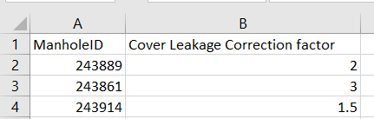
If there is no change on any $S_{o}$, this file can be left to be blank.

2.4.4 Pressure correction factor $S_{DS}$ for specific drop manhole
It is used to change the default value of correction factor $S_{DS}$ for any specific drop manholes. If user wants to change the default value of $S_{DS}$ for all drop manholes, it can be done at GUI of “Global Values”. The values can be inputted manually or uploaded with file *.csv at the interface.
The format of file *.csv is as follows. This file is a two-column Excel file. Starting from second row, the first column is the drop manhole IDs of which $S_{DS}$ will be changed, and the second column is the corresponding value of $S_{DS}$ the user wishes to change into.
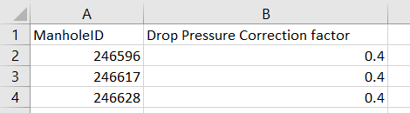
If there is no change on any $S_{DS}$, this file can be left to be blank.

2.5 GUI of Boundary Conditions
The file *.csv is used to input the boundary conditions at any boundary manholes or boundary junctions.
The example of file format is as follows.
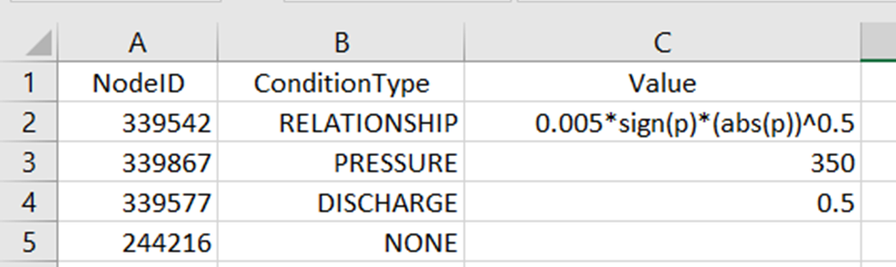
It is a three-column Excel file. The first column lists the node IDs which can be either boundary manhole or boundary junction. The second column specifies one of five types of boundary condition described as follows. The third column specifies the corresponding value of each boundary manhole or boundary junction:
- PRESSURE: The pressure at boundary node is specified, so the value is the specified pressure, the unit is Pa. Be advised that the pressure is the relative pressure related to the atmospheric pressure and at the ground level.
- DISCHARGE: The air flowrate flowing into or out of the boundary node is specified, so the value is the specified air flowrate, the unit is m³/s. Be advised the sign of air flowrate is required to indicate the air flow direction. If air in the connected pipes flows into the node, the value is negative; if air flows out of the node, the value is possible. For example, node #339577 in the example of file format is an upstream boundary junction, the value of 0.5 means air flows out of the node at a flowrate of 0.5 m³/s. But if it is an downstream boundary node as shown in the following figure, air flows into the node, the value in the 3rd column should be $-0.5$ m³/s.
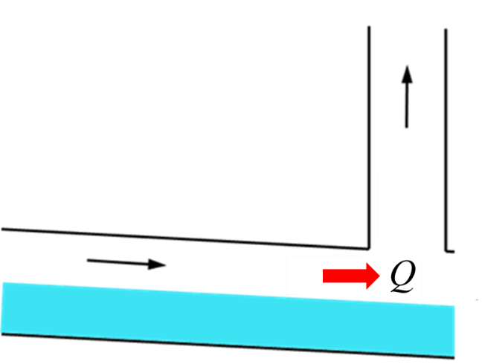
Figure Schematic plot of downstream boundary manhole.
- RELATIONSHIP: It means a relationship between the air pressure and air flowrate will be given as $Q_{cut}=f(p)$ at this node. Be advised that $p$ in this relationship is the relative pressure and not the piezometric pressure, and is the pressure located at the level of removed lateral. The sign of air flowrate is needed to be concerned.
- NONE: It indicates the boundary manholes will be treated as standard manholes, and boundary junctions will be treated as pipe deadends. Leave its value in 3rd column to be blank.
If there is no boundary manhole or boundary junction in the computed sewer system, this file can be left to be blank.

3 Files for Output
The current tool outputs the simulated results via Excel files as listed in the following Table.
Table Outputted files
File Name | Descriptions
pipeOut.csv | To output the related original data and the simulated air flowrate in each pipe, air pressures and air piezometric pressures at both ends of each pipe.
calcStdManholeOut.csv | To output the related original data and the simulated air pressure and air piezometric pressure in manhole, the air flowrate via manhole cover opening.
calcDropMHOut.csv | To output the related original data and the simulated air pressure and air piezometric pressure in drop manhole, the air flowrate via manhole cover opening and in the shaft below drop node.
junctionOut.csv | To output the related original data and the simulated air pressure and air piezometric pressure at junction.
boundaryMHOut.csv | To output the related original data and the simulated air pressure and air piezometric pressure in the manhole, the air flowrate via manhole cover opening
boundaryJunctOut.csv | To output the related original data and the simulated air pressure and air piezometric pressure at the junction.

3.1 pipeOut.csv
File pipeOut.csv is a 32-column Excel file, in which the first 27-column are the inputted original data, and the left 5-column show the simulated air flowrate in each pipe and air pressures at pipe ends.
The example of file pipeOut.csv is as follows.
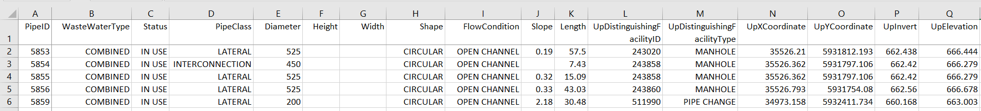
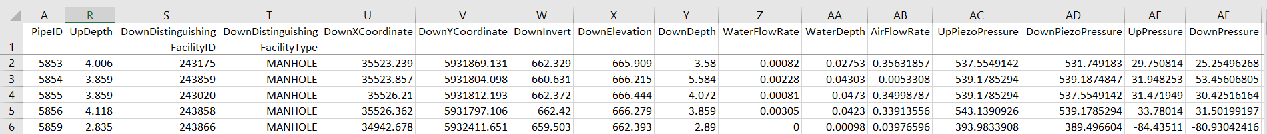
The results in column 28 to 32 are:
- AirFlowRate: The simulated air flowrate in each pipe. It is positive when air flow is concurrent with water flow direction, and negative when air flow is against water flow direction. The unit is m³/s.
- UpPiezoPressure: The air piezometric pressure at the upstream end of each pipe. The unit is Pa.
- DownPiezoPressure: The air piezometric pressure at the downstream end of each pipe. The unit is Pa.
- UpPressure: The relative air pressure at the upstream end of each pipe (at the center level of airspace). The unit is Pa.
- DownPressure: The relative air pressure at the downstream end of each pipe (at the center level of airspace). The unit is Pa.

3.2 calcStdManholeOut.xlsx
It is a 20-column Excel file, in which the first 15-column are the inputted original data, and the left 5-columns mainly show the simulated air pressures in each manhole and air flowrate via manhole cover.
The example of file calcStdManholeOut.xlsx is as follows.
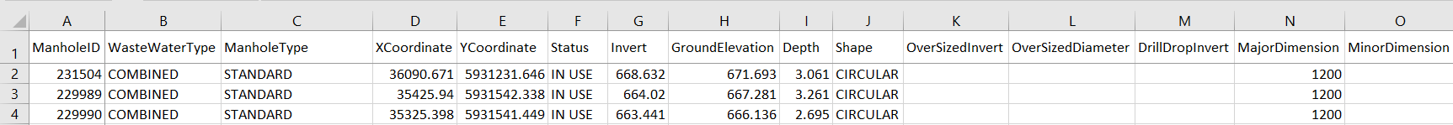
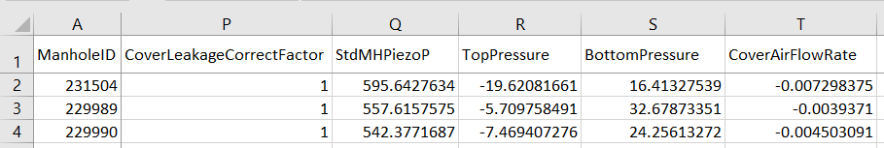

The results in column 16 to 20 are:
- CoverLeakageCorrectFactor: The final value of $S_{o}$ in Eq. 4 after the possible change.
- StdMHPiezoP: The air piezometric pressure in manhole. The unit is Pa.
- TopPressure: The relative air pressure at the top of manhole (ground level). The unit is Pa.
- BottomPressure: The relative air pressure at the bottom of manhole (invert level). The unit is Pa.
- CoverAirFlowRate: The air flowrate released from (positive) or suck into (negative) the sewer system via the manhole cover opening/pickholes. The unit is m³/s.

3.3 calcDropMHOut.csv
It is a 26-column Excel file, in which the first 15-column are the inputted original data, and the left 11-columns mainly show the simulated air pressures in drop manhole and air flowrate via manhole cover.
The example of file calcDropMHOut.csv is as follows.
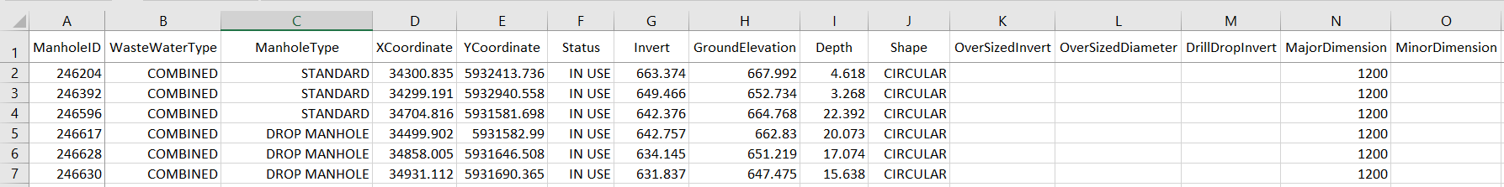
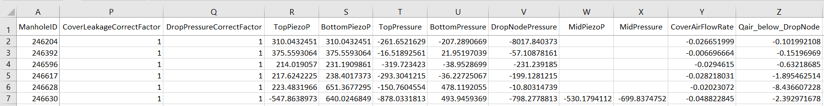
The results in column 16 to 26 are:
- CoverLeakageCorrectFactor: The final value of $S_{o}$ in Eq. 4 after the possible change.
- DropPressureCorrectFactor: The final value of $S_{DS}$ in Eq. 5 after the possible change.
- TopPiezoP: The air piezometric pressure above the averaged level of all lateral drop nodes (excluding trunk drop node) of drop manhole, $P_{m}$ in Eq. 5. The unit is Pa.
- BottomPiezoP: The air piezometric pressure at the bottom of drop manhole, $P_{mb}$ in Eq. 5. The unit is Pa.
- TopPressure: The relative air pressure at the top (ground level) of drop manhole. The unit is Pa.
- BottomPressure: The relative air pressure at the bottom (invert level) of drop manhole. The unit is Pa.
- DropNodePressure: The relative air pressure at the averaged level of all lateral drop nodes (excluding trunk drop node) of drop manhole. The unit is Pa.
- MidPiezoP: The air piezometric pressure at the trunk drop node of drop manhole. The unit is Pa.
- MidPressure: The relative air pressure at the trunk drop node of drop manhole. The unit is Pa.
- CoverAirFlowRate: The air flowrate released from (positive) or suck into (negative) the sewer system via the manhole cover opening/pickholes. The unit is m³/s.
- Qair_below_DropNode: The air flowrate below all drop nodes, $Q_{m}$ in Figure 5, positive if air flows upwards and negative if air flows downwards. The unit is m³/s.

3.4 junctionOut.xlsx
It is a 8-column Excel file, in which the first 6-column are the inputted original data, and the left 2-columns mainly show the simulated air pressures at junctions.
The example of file junctionOut.csv is as follows.
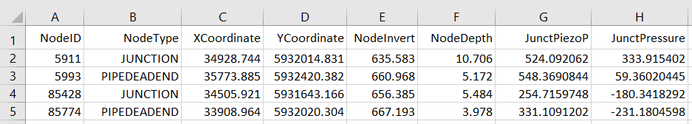
The last two columns are:
- JunctPiezoP: The air piezometric pressure at the junction. The unit is Pa.
- JunctPressure: The relative air pressure at the junction (invert level). The unit is Pa.

3.5 boundaryMHOut.xlsx
It is a 24-column Excel file, in which the first 15-column are the inputted original data, and the left 9-columns mainly show the inputted boundary conditions and the simulated air pressures in boundary manholes and the air flowrate via manhole cover.
The example of file boundaryMHOut.csvis as follows.
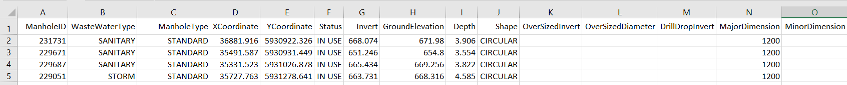
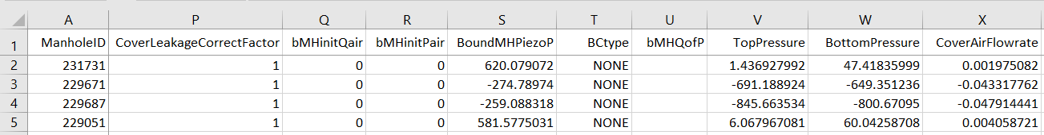
The last 9-columns are:
- CoverLeakageCorrectFactor: The final value of $S_{o}$ in Eq. 4 after the possible change.
- bMHinitQair: The specified air flowrate by user if boundary type (BCtype in this file) x is DISCHARGE. The unit is m³/s.
- bMHinitPair: The specified relative air pressure by user if boundary type is PRESSURE. The unit is Pa.
- BoundMHPiezoP: The simulated air piezometric pressure in the boundary manhole. The unit is Pa.
- BCtype: The boundary type.
- bMHQofP: The relationship $Q=f(p)$ defined by user at the boundary manhole if boundary type is RELATIONSHIP.
- TopPressure: The simulated air pressure at the top of boundary manhole (ground level). The unit is Pa.
- BottomPressure: The simulated air pressure at the bottom of boundary manhole (invert level). The unit is Pa.
- CoverAirFlowrate: The air flowrate released from (positive) or suck into (negative) the sewer system via the manhole cover opening/pickholes. The unit is m³/s.

3.6 boundaryJunctOut.xlsx
It is a 12-column Excel file, in which the first 5-column are the inputted original, and the left 7-columns mainly show the inputted boundary conditions and the simulated air pressures at the boundary junctions.
The example of file boundaryJunctOut.csv is as follows.
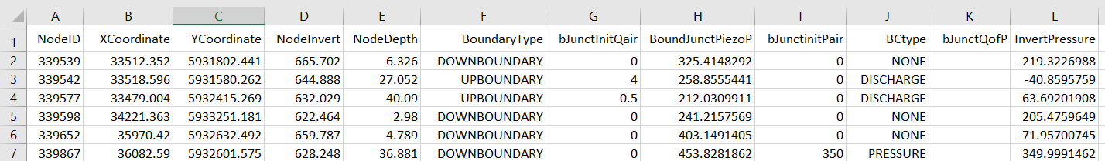
The last 7-columns are:
- BoundaryType: Indicating it is an upstream or downstream boundary junction (relative to the water flow direction).
- bJunctInitQair: The specified air flowrate by user if boundary type (BCtype in this file) is DISCHARGE. The unit is m³/s.
- BoundJunctPiezoP: The simulated air piezometric pressure at the boundary junction. The unit is Pa.
- bJunctinitPair: The specified relative air pressure by user if boundary type is PRESSURE. The unit is Pa.
- BCtype: The boundary type.
- bJunctQofP: The relationship $Q=f(p)$ defined by user at the boundary junction if boundary type is RELATIONSHIP.
- InvertPressure: The simulated air pressure at boundary junction (invert level). The unit is Pa.

